EDS Lab Assignments

Practical 3
Name: Aditya Rajeshwar Werulkar PRN: 202501110208

Numpy Array Operations

Problem Statement:
Write a Python program to create a NumPy array based on user input and display the following:
      - The created NumPy array.
      - The number of dimensions of the array using ndim
      - The shape of the array using shape
      - The total number of elements in the array using size Assume all input elements are valid integers.

Input Format:
      - The first line contains two space-separated integers r and c, representing the number of rows and the number of columns.
      - The next r lines contain c space-separated integers representing the elements of the array, entered row by row.

Output Format:
      - The created NumPy array (printed as a 2D array).
      - An integer representing the number of dimensions of the array.
      - A tuple representing the shape of the array.
      - An integer representing the total number of elements in the array.

Code:
import numpy as np
rows, cols = map(int, input().split()) elements = []

for _ in range (rows):
elements.extend(map(int, input().split()))

array = np.array(elements).reshape(rows, cols) print(array)

print(array.ndim) print(array.shape) print(array.size)

Output:

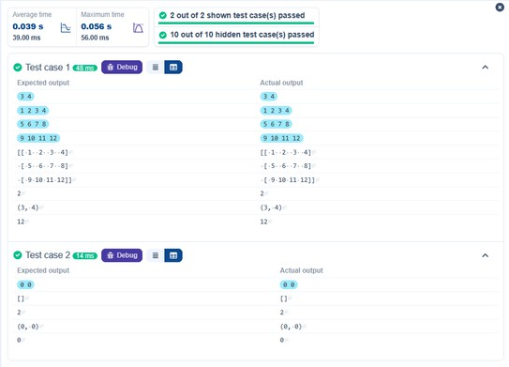

Numpy: Matrix Operations

Problem Statement:
The given code takes two 3×3 matrices, matrix_a, and matrix_b, as input from the user and converts them into NumPy arrays.

Task:
You are required to compute and display the results of the following matrix operations:
      - Addition (matrix_a + matrix_b)
      - Subtraction (matrix_a – matrix_b)
      - Element-wise Multiplication (matrix_a * matrix_b)
      - Matrix Multiplication (matrix_a · matrix_b)

Transpose of Matrix A

Input Format:
        - The user will input 3 rows for matrix_a, each containing 3 integers separated by spaces.
        - Similarly, the user will input 3 rows for matrix_b, each containing 3 integers separated by spaces.

Output Format:
The program should display the results of the operations in the following order:
- The result of Addition.
- The result of Subtraction.
- The result of Element-wise Multiplication.
- The result of Matrix Multiplication.
- The Transpose of Matrix A.

Code:
import numpy as np

# Input matrices
print("Enter Matrix A:")
matrix_a = np.array([list(map(int, input().split())) for i in range(3)]) print("Enter Matrix B:")
matrix_b = np.array([list(map(int, input().split())) for i in range(3)])

# Addition
addition_result = matrix_a + matrix_b print("Addition (A + B):")
print(addition_result)

# Subtraction
subtraction_result = matrix_a - matrix_b print("Subtraction (A - B):")
print(subtraction_result)

# Multiplication (element-wise)
elementwise_multiplication_result = matrix_a * matrix_b print("Element-wise Multiplication (A * B):") print(elementwise_multiplication_result)

# Matrix multiplication (dot product)
matrix_multiplication_result = np.dot(matrix_a, matrix_b) print("A dot B:")
print(matrix_multiplication_result)

# Transpose
transpose_a = matrix_a.T print("Transpose of A:") print(transpose_a)

Output:

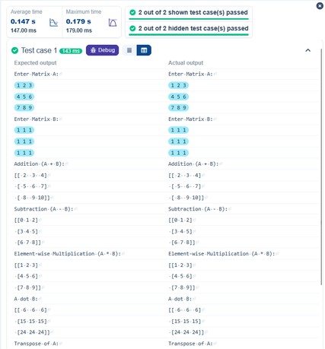

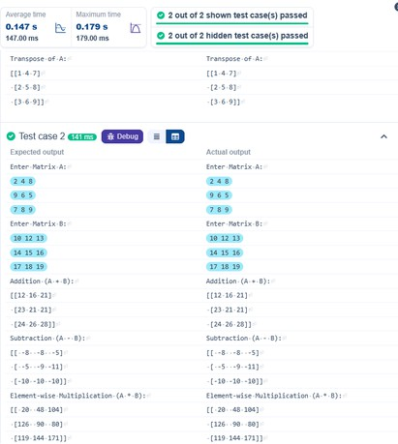

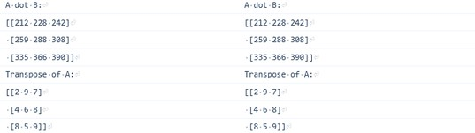

Numpy: Horizontal and Vertical Stacking of Arrays

Problem Statement:

You are given two arrays arr1 and arr2. You need to perform horizontal and vertical stacking operations on them using NumPy.
- Horizontal Stacking: Stack the two matrices horizontally (side by side).
- Vertical Stacking: Stack the two matrices vertically (one below the other).

Input Format:
- The program should first prompt the user to input two 3x3 arrays.
- Each array consists of 3 rows, and each row contains 3 space-separated integers.
- The user will input the two arrays row by row.

Output Format:
- The program should display the result of the Horizontal Stack (side-by-side stacking) of the two arrays.
- The program should then display the result of the Vertical Stack (one below the other) of the two arrays.

Code:

import numpy as np

# Input matrices
print("Enter Array1:")

arr1 = np.array([list(map(int, input().split())) for i in range(3)])

print("Enter Array2:")
arr2 = np.array([list(map(int, input().split())) for i in range(3)])

# Perform horizontal stacking (hstack) a = np.hstack((arr1, arr2)) print("Horizontal Stack:")
print(a)

# Perform vertical stacking (vstack) b = np.vstack((arr1, arr2))
print("Vertical Stack:") print(b)

Output:

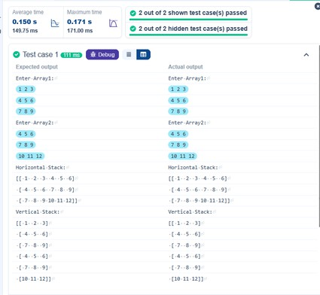

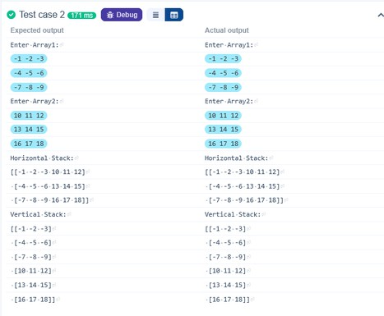

Numpy: Custom Sequence Generation

Problem Statement:
Write a Python program that takes the following inputs from the user:
- Start value: The starting point of the sequence.
- Stop value: The sequence should end before this value.
- Step value: The increment between each number in the sequence.
The program should then generate a sequence using numpy based on these inputs and print the generated sequence.

Input Format:
- The user will input three integer values: start, stop, and step, each on a new line.

Output Format:
- The program should print the generated sequence based on the input values.

Code:
import numpy as np

# Take user input for the start, stop, and step of the sequence start = int(input())
stop = int(input())
step = int(input())
# Generate the sequence using np.arange() a = np.arange(start, stop, step)
# Print the generated sequence
print(a)

Output:

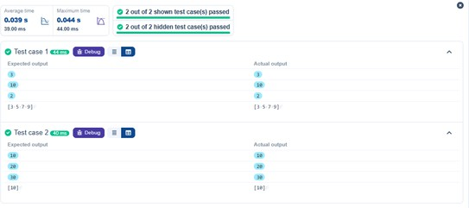

Numpy: Arithmetic and Statistical Operations, Mathematical Operations and Bitwise Operators

Problem Statement:
You are given two arrays A and B. Your task is to complete the function array_operations, which will convert these lists into NumPy arrays and perform the following operations:

Arithmetic Operations:
  - Compute the element-wise sum, difference, and product of the two arrays.

Statistical Operations:
  - Calculate the mean, median, and standard deviation of array A.

Bitwise Operations:
  - Perform bitwise AND, bitwise OR, and bitwise XOR on the arrays (ex: Ai OR Bi).

Input Format:
  - The first line contains space-separated integers representing the elements of array A.
  - The second line contains space-separated integers representing the elements of array B.

Output Format:
  - For each operation (arithmetic, statistical, and bitwise), print the results in the specified format as shown in sample test cases.

Code:
import numpy as np

def array_operations(A, B):
# Convert A and B to NumPy arrays
A = np.array(A)
B = np.array(B)

# Arithmetic Operations sum_result = A + B
diff_result = A - B
prod_result = A * B

# Statistical Operations mean_A = np.mean(A) median_A = np.median(A) std_dev_A = np.std(A)

# Bitwise Operations and_result = A C B

or_result = A | B xor_result = A ^ B

# Output results with one space between each element print("Element-wise Sum:", ' '.join(map(str, sum_result))) print("Element-wise Difference:", ' '.join(map(str, diff_result))) print("Element-wise Product:", ' '.join(map(str, prod_result)))

print(f"Mean of A: {mean_A}") print(f"Median of A: {median_A}")
print(f"Standard Deviation of A: {std_dev_A}")
print("Bitwise AND:", ' '.join(map(str, and_result))) print("Bitwise OR:", ' '.join(map(str, or_result))) print("Bitwise XOR:", ' '.join(map(str, xor_result)))

A = list(map(int, input().split())) # Elements of array A
B = list(map(int, input().split())) # Elements of array B array_operations(A, B)

Output:

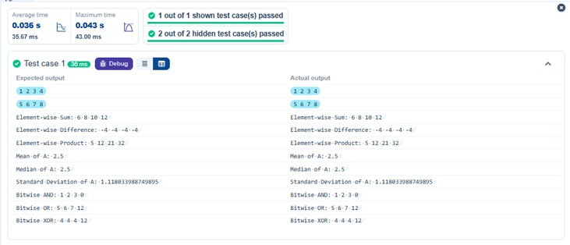

Numpy: Copying and Viewing Arrays

Problem Statement:
The given code takes a list of integers as input and converts it into a NumPy array. Your task is to complete the code by:
- Creating a view of the original_array and assigning it to view_array.
- Creating a copy of the original_array and assigning it to copy_array.

After completing these steps, observe how modifying the view affects the original_array, while modifying the copy does not.

Input Format:
- A single line of space-separated integers.

Output Format:
- After modifying the view:
Original array after modifying view: <original_array> View array: <view_array>
- After modifying the copy:

Original array after modifying copy: <original_array> Copy array: <copy_array>

Code:
import numpy as np
inputlist = list(map(int,input().split(" ")))

# Original array
original_array = np.array(inputlist)

# Create a view
view_array = original_array.view()

# Create a copy
copy_array = original_array.copy()

# Modify the view view_array[0] = 99
print("Original array after modifying view:", original_array) print("View array:", view_array)

# Modify the copy copy_array[1] = 88
print("Original array after modifying copy:", original_array) print("Copy array:", copy_array)

Output:

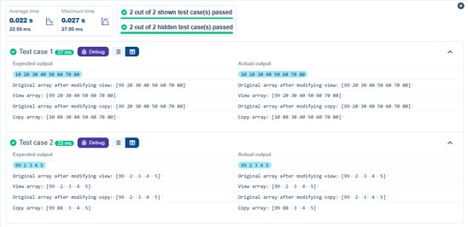

Searching, Sorting, Counting, Broadcasting

Problem Statement:
The given code in the editor takes a single array, array1, as space-separated integers as input from the user.

Additionally, it takes the following inputs:
- search_value: The value to search for in the array.
- count_value: The value to count its occurrences in the array.
- broadcast_value: The value to add for broadcasting across the array.

You need to complete the code to perform the following operations:
- Searching: Find the indices where search_value appears in array1 and print these indices.
- Counting: Count how many times count_value appears in array1 and print the count.
- Broadcasting: Add broadcast_value to each element of array1 using broadcasting, and print the resulting array.
- Sorting: Sort array1 in ascending order and print the sorted array.

Input Format:
  - A single line containing space-separated integers representing array1.
  - An integer search_value represents the value to search for in the array.
  - An integer count_value represents the value to count in the array.
  - An integer broadcast_value represents the value to add to each element of the array.

Output Format:
- The indices where search_value occurs in array1.
- The count of occurrences of count_value in array1.
- The array after adding the broadcast_value to each element.
- The sorted array.

Code:
import numpy as np

# Input array from the user
array1 = np.array(list(map(int, input().split())))

# Searching
search_value = int(input("Value to search: ")) count_value = int(input("Value to count: "))
broadcast_value = int(input("Value to add: "))

# Find indices where value matches in array1 a = np.where(array1 == search_value)[0] print(a)

# Count occurrences in array1
b = np.count_nonzero(array1 == count_value) print(b)

# Broadcasting addition
c = array1 + broadcast_value print(c)

# Sort the first array d = np.sort(array1) print(d)

Output:

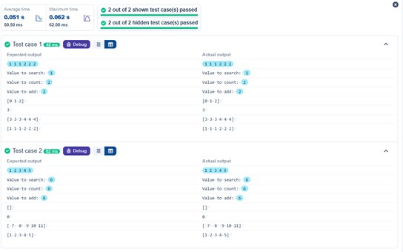

Student Data Analysis and Operations

Problem Statement:
Write a Python program that takes the file name of a CSV file containing student details, including roll numbers and their marks in three subjects as input, reads the data, and performs the following
operations:
- Print all student details: Display the complete details of all students, including roll numbers and marks for all subjects.
- Find total students: Determine the total number of students in the dataset.
- Print all student roll numbers: Extract and print the roll numbers of all students.
- Print Subject 1 marks: Extract and print the marks of all students in Subject 1.
- Find minimum marks in Subject 2: Identify the lowest marks in Subject 2.
- Find maximum marks in Subject 3: Identify the highest marks in Subject 3.
- Print all subject marks: Display the marks of all students for each subject.
- Find total marks of students: Compute the total marks for each student across all subjects.
- Find the average marks of each student: Compute the average marks for each student.
- Find average marks of each subject: Compute the average marks for all students in each subject.
- Find average marks of Subject 1 and Subject 2: Compute the average marks for Subject 1 and Subject 2.

- Find average marks of Subject 1 and Subject 3: Compute the average marks for Subject 1 and Subject 3.
- Find the roll number of the student with maximum marks in Subject 3: Identify the student with the highest marks in Subject 3 and print their roll number.
- Find the roll number of the student with minimum marks in Subject 2: Identify the student with the lowest marks in Subject 2 and print their roll number.
- Find the roll number of students who scored 24 marks in Subject 2: Identify students who obtained exactly 24 marks in Subject 2 and print their roll numbers.
- Find the count of students who got less than 40 marks in Subject 1: Count the number of students who scored less than 40 marks in Subject 1.
- Find the count of students who got more than G0 marks in Subject 2: Count the number of
students who scored more than 90 marks in Subject 2.
- Find the count of students who scored >=G0 in each subject: Count the number of students who scored 90 or more marks in each subject.
- Find the count of subjects in which each student scored >=G0: Determine how many subjects
each student scored 90 or more marks in.
- Print Subject 1 marks in ascending order: Sort and print the marks of students in Subject 1 in ascending order.
- Print students who scored between 50 and G0 in Subject 1: Display students who scored marks between 50 and 90 in Subject 1.
- Find index positions of students who scored 7G in Subject 1: Identify the index positions of students who scored exactly 79 marks in Subject 1.

Code:
import numpy as np

a = np.loadtxt("Sample.csv", delimiter=',', skiprows=1)

roll = a[:, 0].astype(float) s1 = a[:, 1]
s2 = a[:, 2]
s3 = a[:, 3]

# 1. Print all student details
print("All student Details:\n", a)

# 2. print total students
print("Total Students:", len(a))

# 3. Print all student Roll numbers print("All Student Roll Nos", roll)

# 4. Print subject 1 marks print("Subject 1 Marks", s1)

# 5. print minimum marks of Subject 2 print("Min marks in Subject 2", np.min(s2))

# 6. print maximum marks of Subject 3 print("Max marks in Subject 3", np.max(s3))

# 7. Print All subject marks
print("All subject marks:", a[:, 1:])

# 8. print Total marks of students total = s1 + s2 + s3
print("Total Marks", total)

# 9. print average marks of each student print(np.round(total/3, 1))

# 10. print average marks of each subject
print("Average Marks of each subject", np.mean(a[:, 1:], axis = 0))

# 11. print average marks of S1 and S2
print("Average Marks of S1 and S2", np.mean([s1, s2], axis = 1))

# 12. print average marks of S1 and S3
print("Average Marks of S1 and S3", np.mean([s1, s3], axis = 1))

# 13. print Roll number who got maximum marks in Subject 3
print("Roll no who got maximum marks in Subject 3", float(roll[np.argmax(s3)]))

# 14. print Roll number who got minimum marks in Subject 2
print("Roll no who got minimum marks in Subject 2", float(roll[np.argmin(s2)]))

# 15. print Roll number who got 24 marks in Subject 2
print("Roll no who got 24 marks in Subject 2",roll[s2 == 24].astype(float).reshape(1, -1))

# 16. print count of students who got marks in Subject 1 < 40
print("Count of students who got marks in Subject 1 < 40", np.sum(s1 < 40))

# 17. print count of students who got marks in Subject 2 > 90
print("Count of students who got marks in Subject 2 > 90:", np.sum(s2 > 90))

# 18. print count of students in each subject who got marks >= 90
print("Count of students in each subject who got marks >= 90:", np.sum(a[:, 1:] >= 90, axis = 0))

# 19. print count of subjects in which each student got marks >= 90 print("Roll no:", roll)
print("Count of subjects in which student got marks >= 90:", np.sum(a[:, 1:] >= 90, axis = 1))

# 20. Print S1 marks in ascending order print(np.sort(s1))

# 21. Print S1 marks >= 50 and <= 90
print(a[(s1 >= 50) C (s1 <= 90)].astype(float)) print(a.astype(float))

# 22. Print the index position of marks 79 print(np.where(s1 == 79))

Output:

